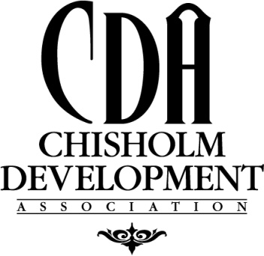

Chisholm Development Association
Revolving Loan Fund

The purpose of the Chisholm Development Association Revolving Loan Fund is to provide loans to businesses looking to expand or locate in the Chisholm/Balkan area. Businesses seeking assistance shall provide benefit to low and moderate income individuals and/or create or retain jobs that benefit low to moderate income individuals. Funds are loaned from a ‘pool’ of funds created by loan repayments of past development projects. Assistance is provided to the private, for profit sector allowing supplementing or maximizing private sources of funding. Loan interest rates are based upon a ‘discounted rate’ which follows the prime lending rate.

Application information required include the CDA Loan Form, a business plan, two years tax returns (both business & personal) or a local bank reference letter.

Application documents should be provided to:

Stephanie Skraba, Economic Development Coordinator,
Chisholm City Hall, 316 West Lake Street, Chisholm, MN 55719
email: sskraba@ci.chisholm.mn.us phone: 218-254-7960

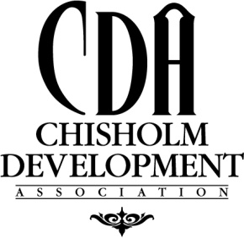

CDA Revolving Loan Program

Information Sheet

- Business Name____________________________________________________

- Business Address___________________________________________________

- Owners Name_____________________________________________________

- Contact Information: Cell___________________________________________

Work___________________________________________

Home___________________________________________

- Business Description_________________________________________________

___________________________________________________________________

___________________________________________________________________

- Property Tax ID# (Parcel Code)________________________________________

- Insurance Carrier_____________________________________________________

- Other Financing______________________________________________________

_____________________________________________________________________

_____________________________________________________________________

- Lender Name & Contact Number ________________________________________

Return Document to: Stephanie Skraba, Economic Development Coordinator, City of Chisholm

